**Worksheet – 1.1**

**Student Name:** Vivek Kumar  **UID:** 21BCS8129

**Branch:** BE-CSE (LEET) **Section/Group:** 808/B

**Semester:** 4th **Date of Performance:** 18/02/2022

**Subject Name:** Programming In Python Lab  **Subject Code:** 20CSP-259

**1. Aim/Overview of the practical:**

1. Write a program c to enter two numbers and perform all arithmetic operations.
2. Write a program to enter marks of five subjects and calculate total, average and percentage.
3. Write a program to enter length in centimeter and convert it into meter and kilometer, and also convert the same into Equivalents

**2. Task to be done/ Which logistics used:**

1. Perform arithmetic operation.
2. Calculate the total, average and percentage.
3. Convert centimeter into meter, kilometer and vice versa.

**3. Steps for experiment/practical/Code:**

1. Perform arithmetic operation.

**Sourse Code:**

num1 = float(input(" Please Enter the First Number: "))

num2 = float(input(" Please Enter the Second Number: "))

add = num1 + num2

sub = num1 - num2

multi = num1 * num2

div = num1 / num2

mod = num1 % num2

expo = num1 ** num2

print("The Sum of {0} and {1} = {2}".format(num1, num2, add))

print("The Subtraction of {0} from {1} = {2}".format(num2, num1, sub))

print("The Multiplication of {0} and {1} = {2}".format(num1, num2, multi))

print("The Division of {0} and {1} = {2}".format(num1, num2, div))

print("The Modulus of {0} and {1} = {2}".format(num1, num2, mod))

print("The Exponent Value of {0} and {1} = {2}".format(num1, num2, expo))

1. Calculate the total, average and percentage.

**Sourse Code:**

english = float(input("Please enter English Marks: "))

math = float(input("Please enter Math score: "))

computers = float(input("Please enter Computer Marks: "))

physics = float(input("Please enter Physics Marks: "))

chemistry = float(input("Please enter Chemistry Marks: "))

total = english + math + computers + physics + chemistry

average = total / 5

percentage = (total / 500) * 100

print("\nTotal Marks = %.2f" %total)

print("Average Marks = %.2f" %average)

print("Marks Percentage = %.2f" %percentage)

1. Convert centimeter into meter, kilometer and vice versa.

**Sourse Code:**

*#Covert centimeters to meters & Kilometers*

cm = input("Enter Length in Centimeters : ")

meter = float(cm)/100

kilometer = float(cm) / 100000

print("Length in meters = " ,meter , "m")

print("Length in Kilometers = ",kilometer , "km")

*#Covert Meters to centimeters & Kilometers*

meter = input("Enter Length in Meters : ")

cm = float(meter)*100

kilometer = float(meter) / 1000

print("Length in Centimeters = " ,cm , "cm")

print("Length in Kilometers = ",kilometer , "km")

*#Covert Kilometers to centimeters & meters*

kilometer = input("Enter Length in Kilometers : ")

meter = float(kilometer)*1000

cm = float(kilometer) * 100000

print("Length in Centimeters = " ,cm , "cm")

print("Length in meters = ",meter , "m")

**4. Result/Output/Writing Summary:**

1. Perform arithmetic operation.

**Output:**

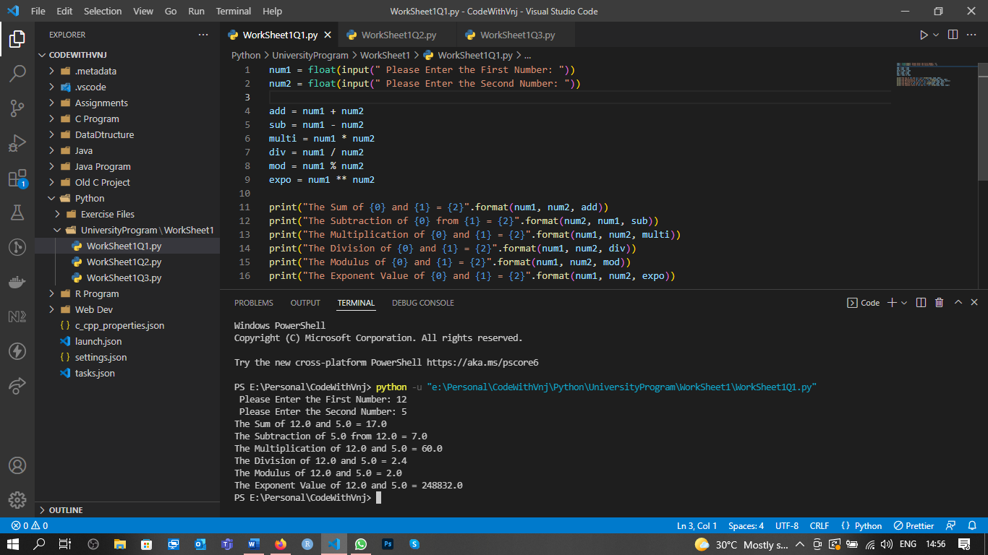

1. Calculate the total, average and percentage.

**Output:**

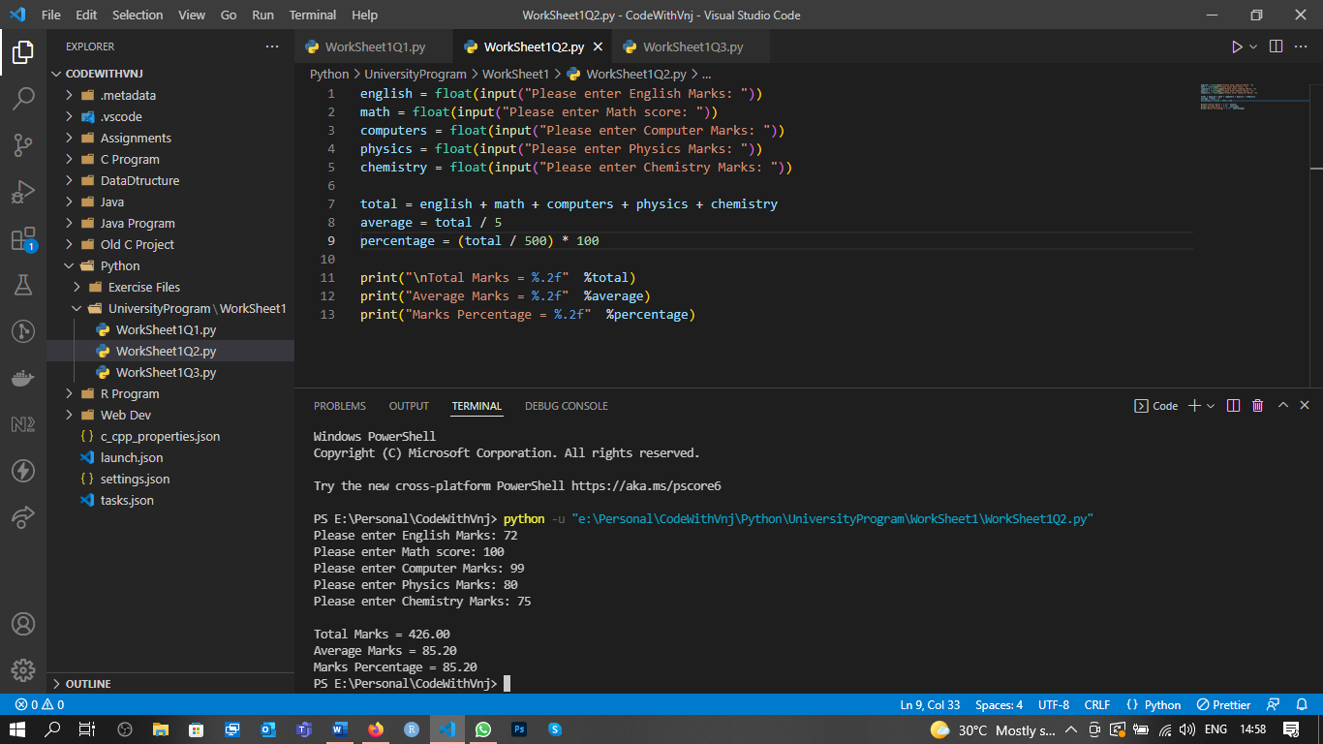

1. **C**onvert centimeter into meter, kilometer and vice versa.

**Output:**

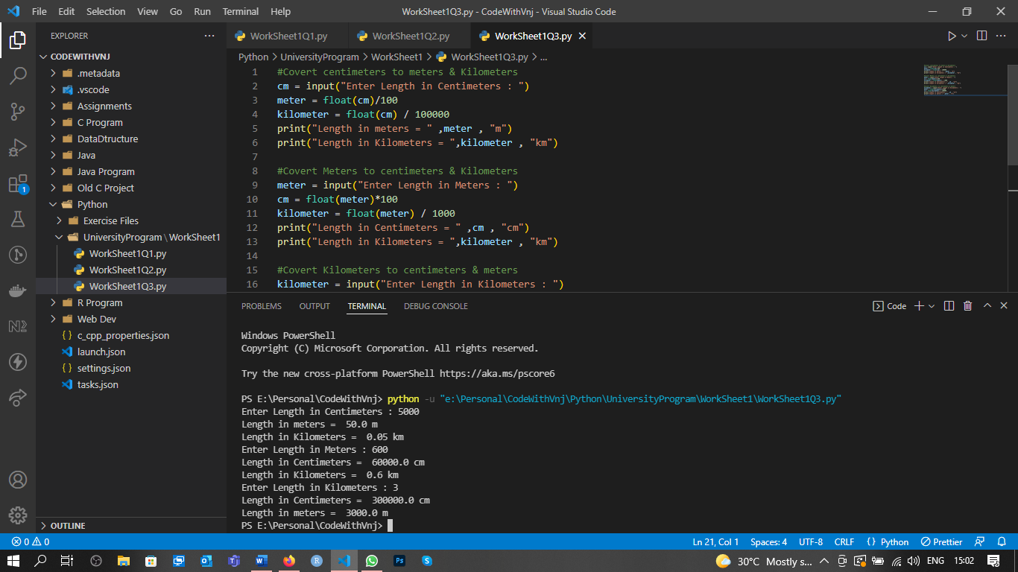

**Learning outcomes (What I have learnt):**

**1.** I have learnt, how to perform Arithmetic Operations on two numbers.

**2.** Learnt to find the Sum, Average and Percentage in python.

**3.** Learnt length conversion using python.

**Evaluation Grid (To be created as per the SOP and Assessment guidelines by the faculty):**

|  |  |  |  |
| --- | --- | --- | --- |
| Sr. No. | Parameters | Marks Obtained | Maximum Marks |
| 1. |  |  |  |
| 2. |  |  |  |
| 3. |  |  |  |
|  |  |  |  |